Assignment 2

Dang Khoa Le
Student ID: 103844421
Major: Bachelor of Software Engineering. Tutorial Wednesday, 06.30PM.

Abstract: This document presenting the demonstration for Assignment 2. The demonstration is based on AWS academy infrastructure.
This assignment will extend/modify the infrastructure and program developed in Assignment 1b.
It has the following additional objectives:
1. Create IAM roles to enable EC2, Lambda, and S3 to interact with each other.
2. Restrict access to S3 using S3 bucket policy.
3. Create a lambda function.
4. Create a custom AMI.
5. Create a launch template based on your custom AMI.
6. Create an auto scaling group across multiple Availability Zones with policies for scaling up and down.
7. Create an elastic load balancer to distribute service requests.
8. Access control and traffic limitations by using AWS NACLs.
I. Creating a VPC:
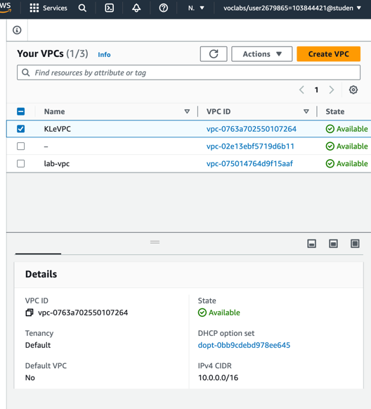
The following images illustrate the configuration of the main VPC for this assignment (named as KLeVPC).
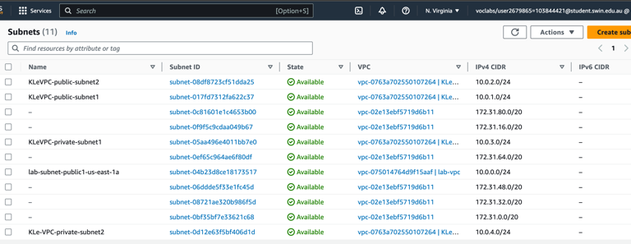
The VPC will be associated by 4 subnets (allocated in 2 subnet groups KLeVPC-rtb-private and KLeVPC-rtb-public). The 4 subnets are KLeVPC-public-subnet1 and KLeVPC-private-subnet1 (us-east1a), KLeVPC-public-subnet2 and KLeVPC-private-subnet2 (us-east1b), which have the IPv4 CIDR of 10.0.1.0/24, 10.0.3.0/24, 10.0.2.0/24, 10.0.4.0/24 by respectively.
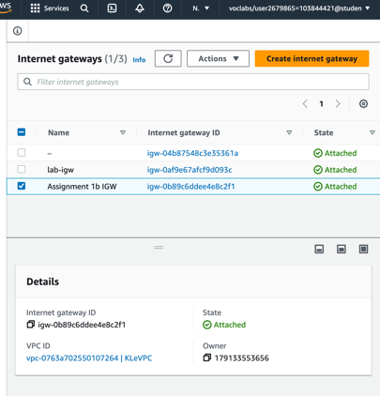
An Internet gateway was created before and named as ‘Assignment 1b IGW’ that attached to the main VPC. This Internet gateway will be associated to the public route table that linking with the 2 public subnets.
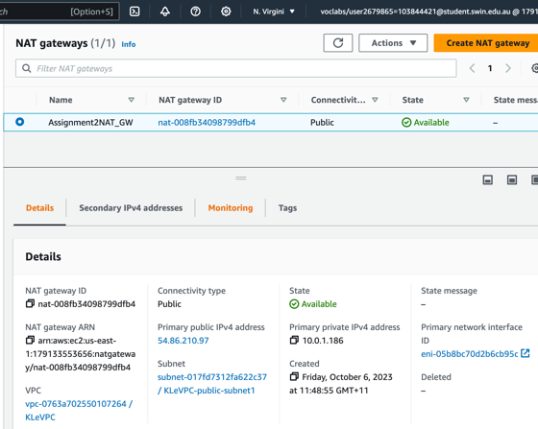
A NAT-gateway also has been created with an attached Elastic IP address. This NAT gateway associates to the private route table that attached to the 2 private subnets. It allows private instances to be able to communicate with the public internet.
Below is the completed Resource map for KLeVPC as indicating their components and how subnets, route tables and network connections (internet and NAT gateways) are integrated in this VPC.
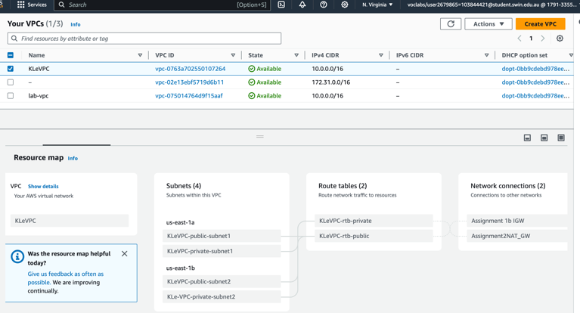
II. Creating The Security Groups:
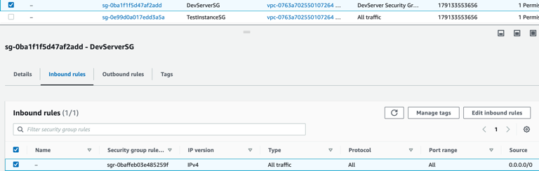
The following images illustrate the configuration of the 4 security groups for this assignment (with KLeVPC).
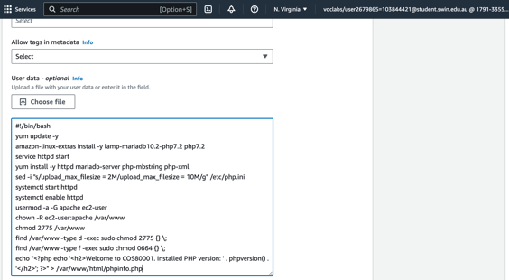
- DevServerSG
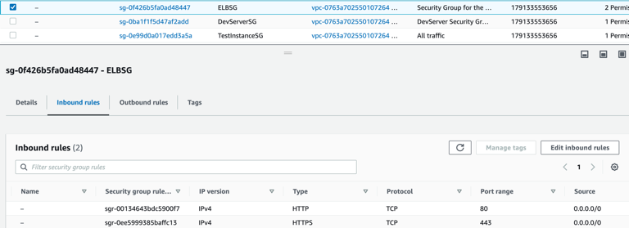
- ELBSG
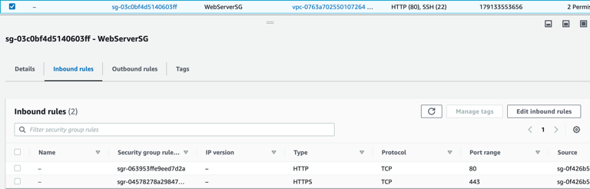
- WebServerSG
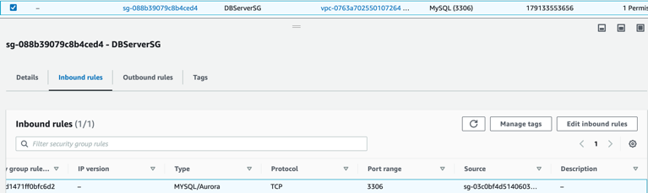
- DBServerSG
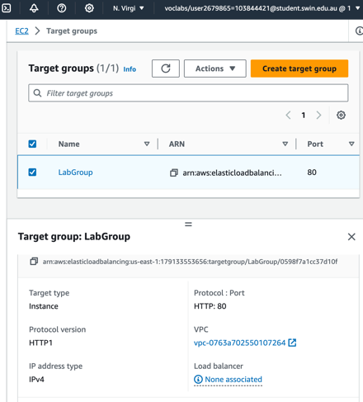
These 4 security groups allow suitable traffics to satisfy the task functionality specifications as well as allows a proper security interfacing. Security groups including DevServerSG (for Dev Server EC2 instance, allows all traffics as this security group doesn’t have to follow the least-privilege principle), ELBSG (for Elastic Load Balancer, allows all HTTP and HTTPS traffics from everywhere), WebServerSG (for the 2 Web Server instances within the private subnets, they allow incoming traffics from ELBSG via HTTP and HTTPS port), and DBServerSG (sourced by WebServerSG, for kle-database, allows MYSQL/Aurora traffics).

II. Create an Dev Server Instance:
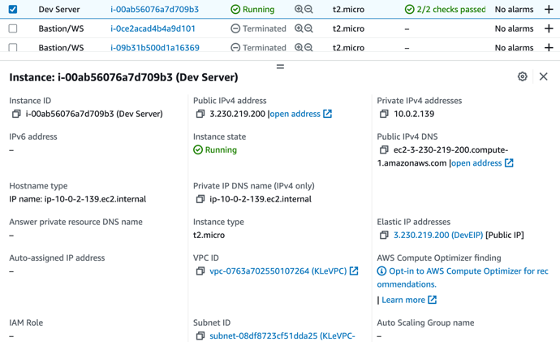
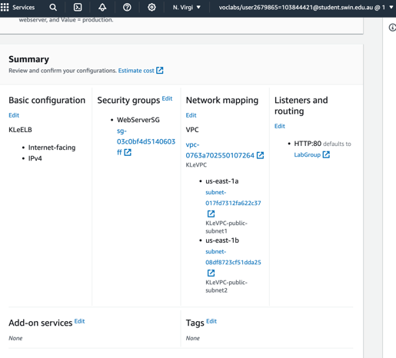
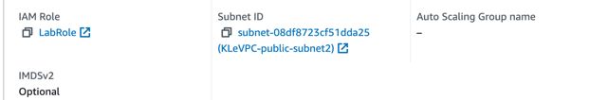
These images illustrate the configuration for the Dev Server and its associations, this instance is needed to create the AMI images and also serve as the public allocation source for the phpMyAdmin and photo up/download functionalities at the later steps. They also has been attached to the IAM -LabRole.
The Dev Server instance is allocated in KLeVPC’s public subnet 2 (KLeVPC-public-subnet2), associated with the DevServerSG security groups and the DevEIP Elastic IP address (providing the fixed public IPv4 DNS for the instance). I also update the user data with the Apache http server and php, installed from the resource of Assignment 1b.
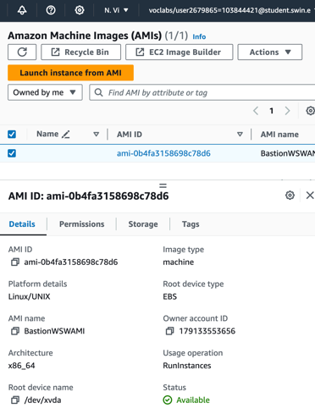
An AMI image also has been created from the Dev Server instance. The following images shows their configurations in detail.
III. Creating The Target Groups, Launch Template and Elastic Load Balancer:
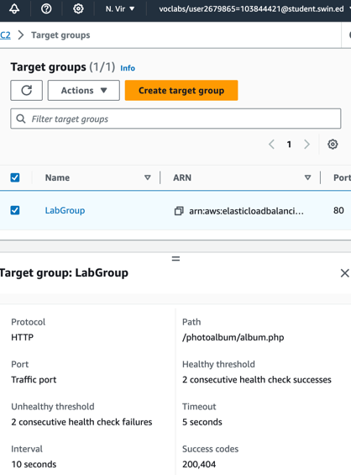
The following images illustrate the configuration for the Target Group ‘LabGroup’. The target group will use WebServerSG and the 2 public subnets, alongside with the HTTP port 80. It also serves the threshold value of 2 consecutive healthy and unhealthy checks.
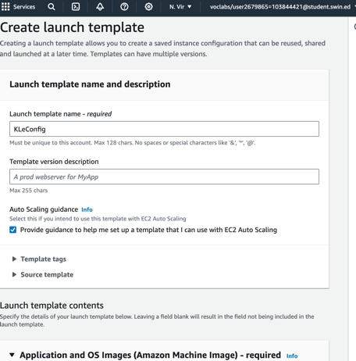
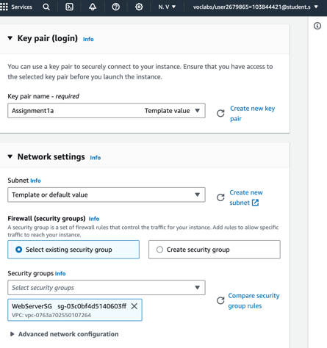
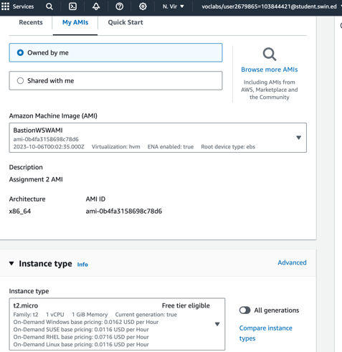
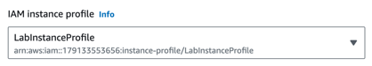
Then, we launch template, named as KLeConfig, which will be used for the Auto Scaling Group in the upcoming step. This template also uses the LabInstanceProfile (IAM LabRole) and allows CloudWatch monitoring, which can be used to keep track on any failure alarms of the 2 Web Server instances.

Nextly, we will create the Auto Scaling Group to initialise the 2 Bastion (Webserver instances) named as ‘Bastion/WS’.

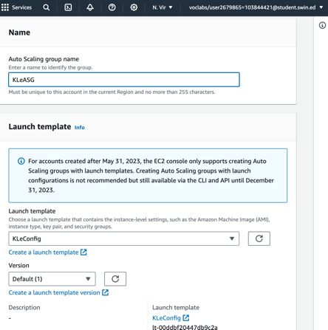
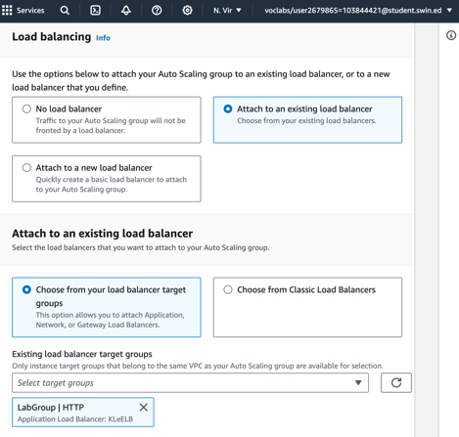
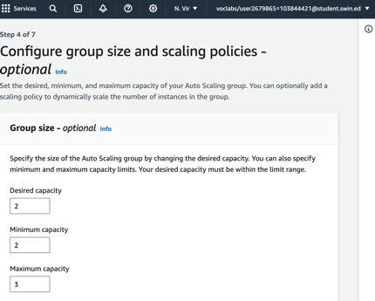
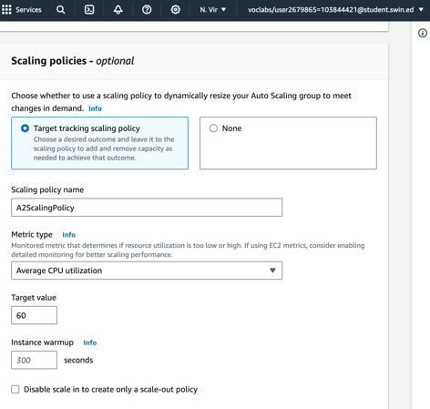
KLeASG will use the KLeConfig template, LabGroup target group, using desired and minimum capacity of 2 alongisde with the maximum of 3 in group size.
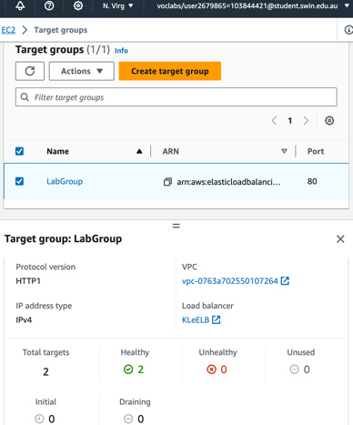
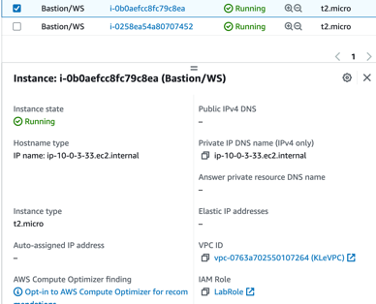
After finishing these steps, there will be 2 Bastion/WS instances automatically pops up on the EC2-Instacnes dashboard. After the 2 instances states showed to be completed, we have to check on the Target group to make sure that both instance shows up as healthy, which allows us to interact with the website via the ELB’s DNS url at the later stages. We should also have to make sure that IAM - LabRole is assigned to the Bastion instances at this stage.
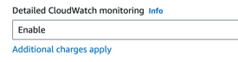
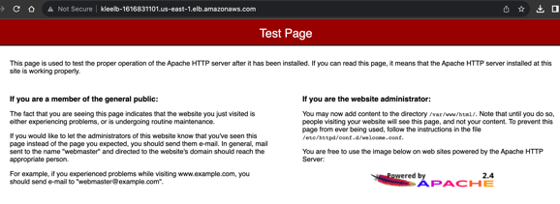
We can also try to access the ELB’s DNS at this stage to ensure they operates properly, which is accessible via:
KLeELB-1616831101.us-east-1.elb.amazonaws.com
IV. Creating The RDS Database:
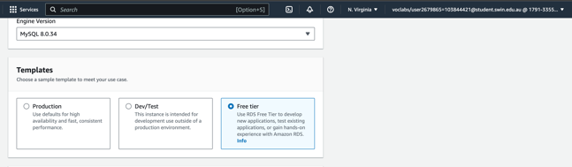
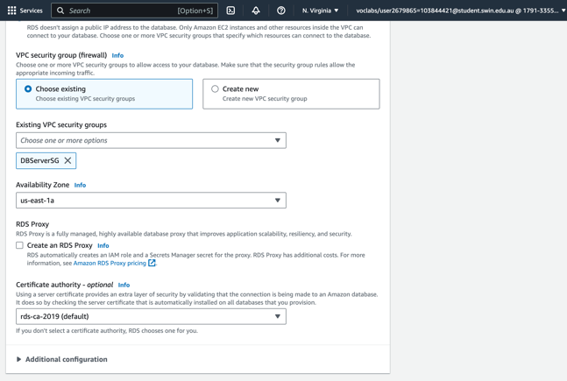
The following images illustrate the configuration for the RDS database and its associations.
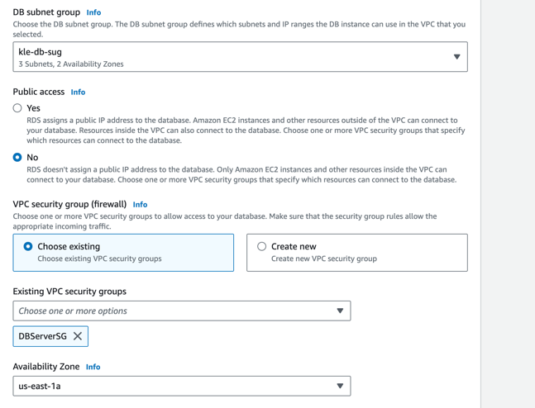
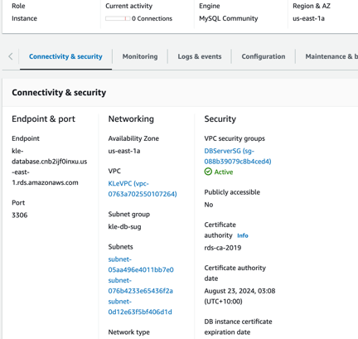
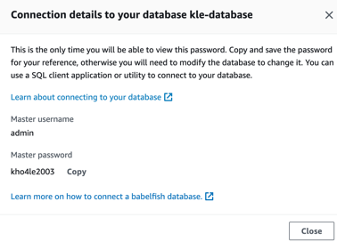
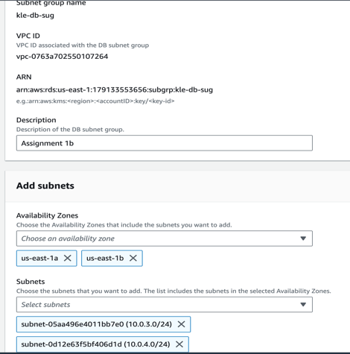
The RDS database is named as kle-database, below is its detailed connectivity and endpoint. The database is associated with the KLeVPC, KLeVPC-private-subnet1 and use the DBServerSG security group.
In advanced to this RDS database, I also have created a subnet group (kle-db-sug) of 2 private subnet (KLeVPC-private-subnet1 and KLeVPC-private-subnet2), this subnet group also use 2 availability zones us-east-1a and us-east-1b, thus it is compatible with the Web Server.

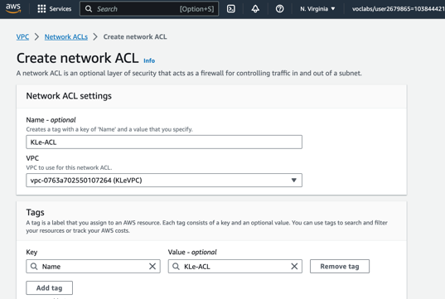
V. Create Network ACL:
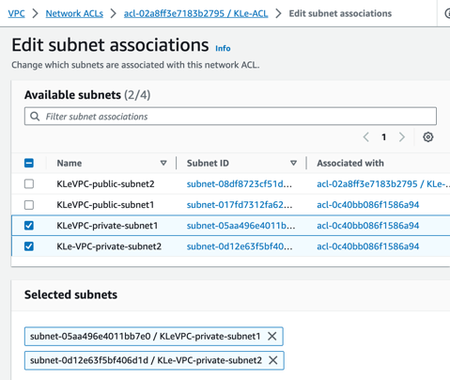
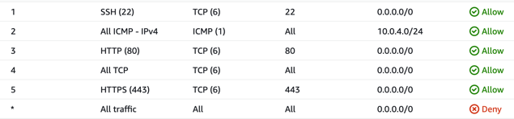
The following images illustrate the configuration for the Network ACL (KLe-ACL) and its inbound rules (Allows SSH, HTTP, HTTPS and ICMP traffics). This NACL will be associated to the 2 private subnets as indicated in Assignment 2 specifications.
VI. Installing phpMyAdmin:
The following images illustrate how I installed phpMyAdmin to the Dev Server.

From the command line of my local terminal, I have to download the phpmyadmin file, then unzip and move them appropriately to the specified directory. Then, logging to my EC2 instance by using the SFTP method and my key pair (pre-named as Assignment1a) on Cyberduck, then moving to the var/www/html/phpmyadmin, locating the file config.sample.inc.php and change the name to, config.inc.php. After that, open the file and edit the line on my terminal to the appropriate RDS endpoint (nano file editor):
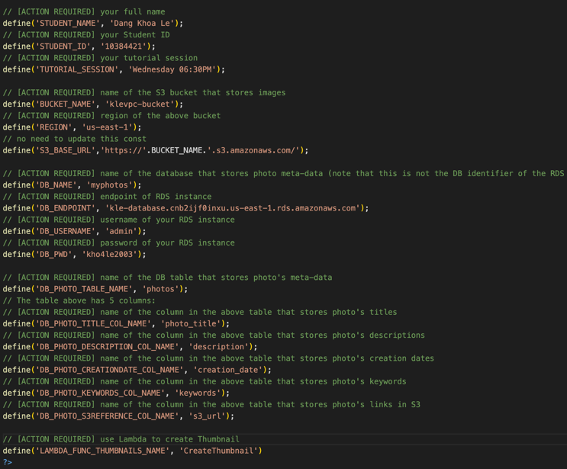
$cfg['Servers'][$i]['host'] = 'localhost';
Into:
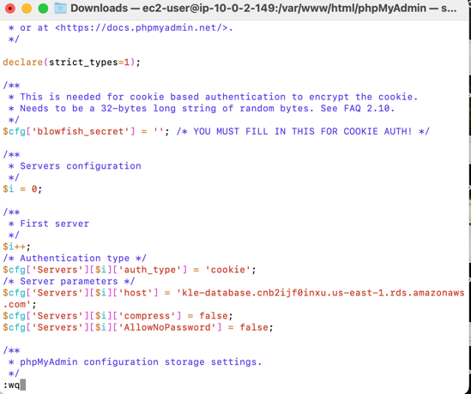
$cfg['Servers'][$i]['host'] = ‘kle-database.cnb2ijf0inxu.us-east-1.rds.amazonaws.com’;
Then I am able to enter the username and password of my DB to login to phpMyAdmin via my Elastic Load Balancer’s Public DNS:
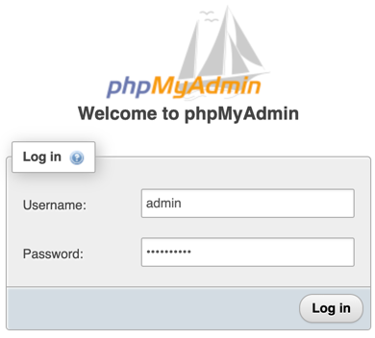
http://KLeELB-1616831101.us-east-1.elb.amazonaws.com/phpmyadmin/

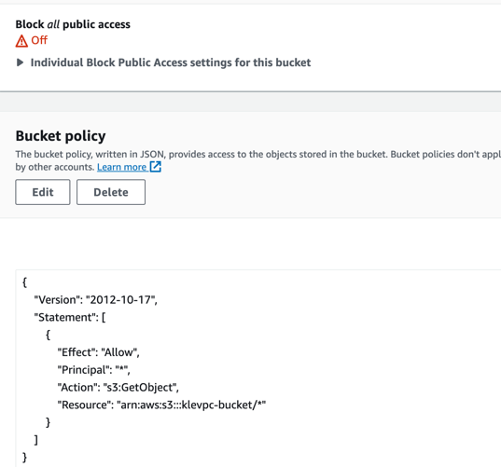
VII. Creating S3 Bucket:
The following images illustrate the configuration for the S3 Bucket named ‘klevpc-bucket’.

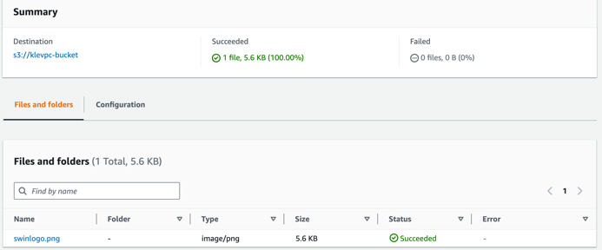

A Swinburne logo is uploaded onto the bucket as above while the bucket’s access policy also has been modified to be publicly accessible.
The Swinburne logo object, also has enabled to be shared with presigned URL:
https://klevpc-bucket.s3.amazonaws.com/swinlogo.png

VIII. Modifying phpMyAdmin Page:
The following images illustrate the modification for the http web-page phpMyAdmin.

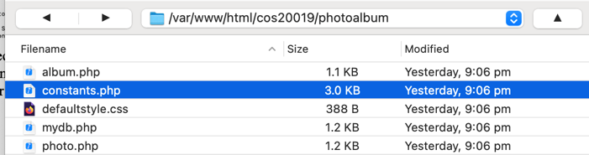
Below are my modification for the file php.constants (edited by Visual Studio Code) and the new table storing my new images named as myphotos.
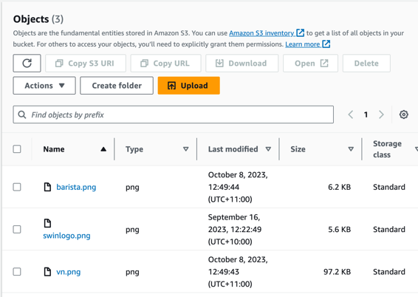
Eventually, the S3 bucket will then store 3 images in total which they will be resized by Lambda.
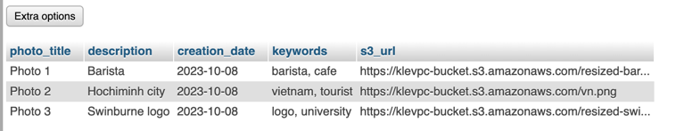
IX. IAM Role And Lambda Configuration:
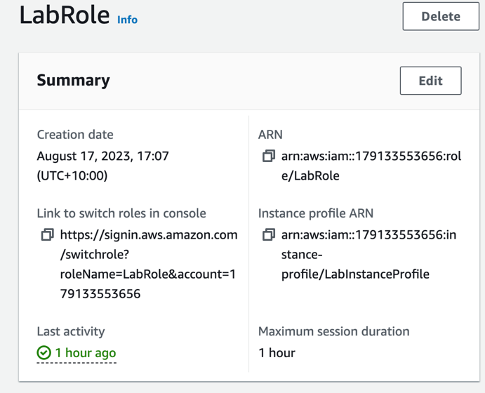
An IAM Role created at default (LabRole) has been previously assigned to allow EC2, Lambda and S3 bucket interaction functioned properly.
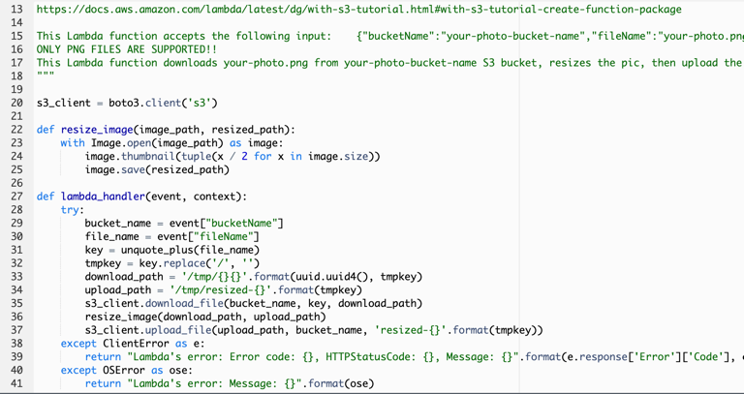
Lambda named “CreateThumbnail’ is configured as below, which use LabRole to integrate with EC2 and S3 bucket. Photos uploaded from the website is resized into appropriate (smaller) size by lambda function. The lambda contains codebase - package provided by default AWS (of this unit) which contains the library and full code resources to resize images and up/download images to S3 (png source based images preferred).
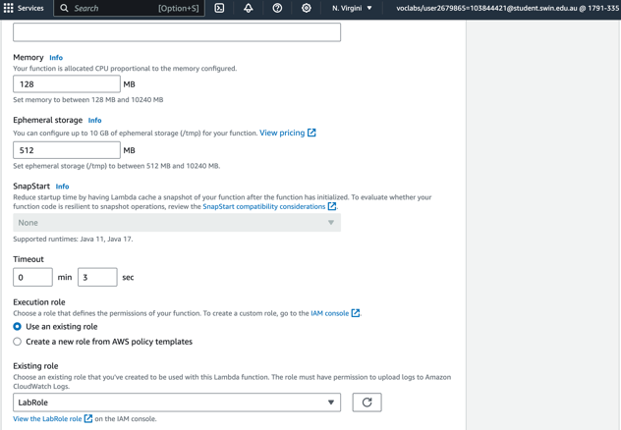
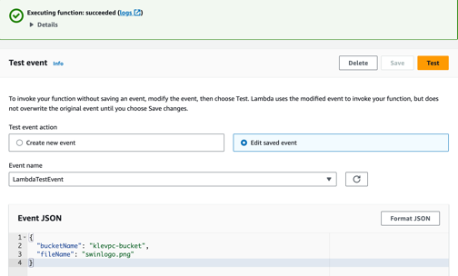
A test code also has been implemented and returns successful.
The resized swinlogo, barista and vn png photos by Lambda can be accessible via these url:
https://klevpc-bucket.s3.amazonaws.com/resized-swinlogo.png
https://klevpc-bucket.s3.amazonaws.com/resized-barista.png
https://klevpc-bucket.s3.amazonaws.com/vn.png

X. Accessing The Photo:
In similar to Assignment 1b, we have to navigate to phpmyadmin and construct a proper table for the photo demonstration. Make sure that they are appropriately formatted and named, while using png is preferable with the integration of the Lambda code.
Apparently, I can access all of my uploaded photos by the following http link:
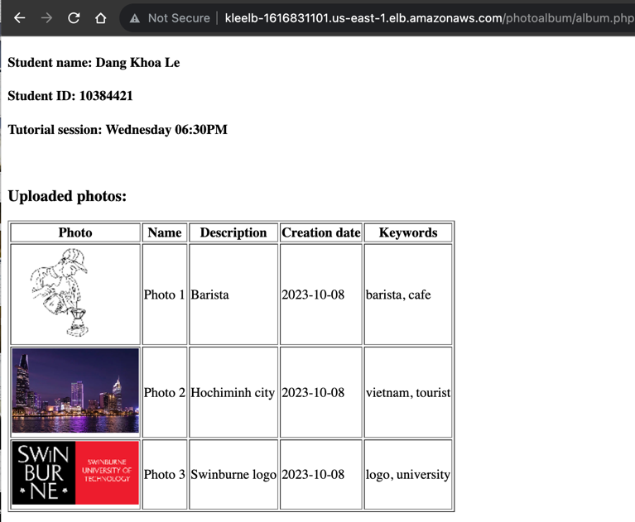
http://kleelb-1616831101.us-east-1.elb.amazonaws.com/cos20019/photoalbum/album.php
(Various figures in this project may simultaneously demonstrate irrelevant topic as they are used as testing, please ignore).

XI. Possible Systematic Errors:
Target Group (LabGroup) could return with unhealthy health check for the 2 Web server instances when the port is not properly configured as 80 (HTTP) or the path is not corrected to be ‘/albumphoto/album.php’, also make sure to set the success code to be 200 (add 404 if the health check still fails).
Make sure that the Elastic Load Balancer (KLeELB) uses the AMI created by Dev Server, or else the ELB’s DNS would not being able to be accessed via web browser.
CloudWatch monitor can also being implemented to check for any possible failures during Assignment 2’s Set-up.

